**BOOK STORE API**

**GET BOOKS** : <https://m6x606vg54.execute-api.us-east-1.amazonaws.com/BookStoreAPI/books>

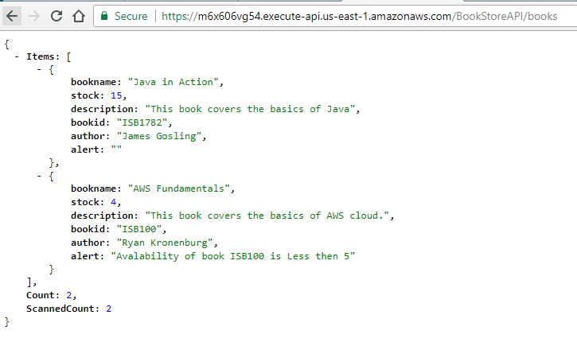

**GET BOOK BY ID** : <https://m6x606vg54.execute-api.us-east-1.amazonaws.com/BookStoreAPI/books/ISB100>

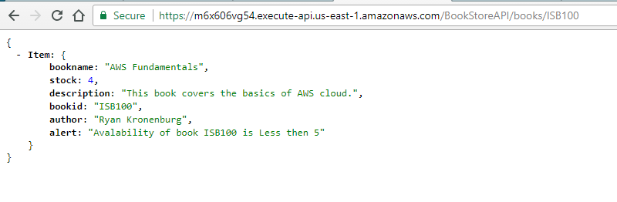

**TEST RESULTS**

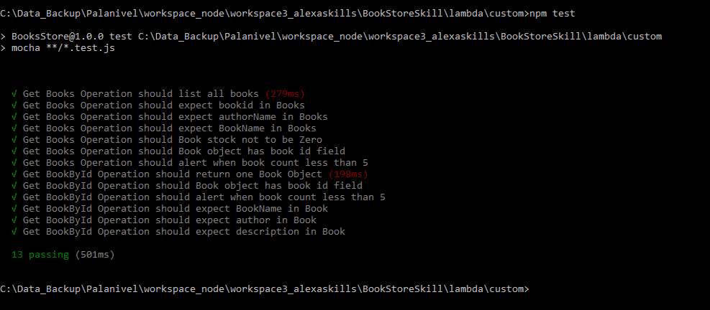

**STANDALONE RUN**

List of all books

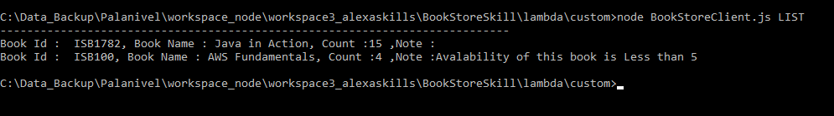

**List book by id**

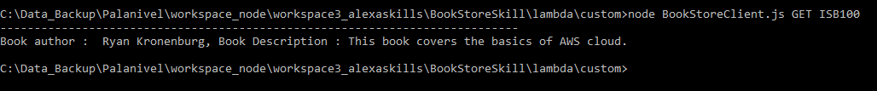

**DynamoDB**

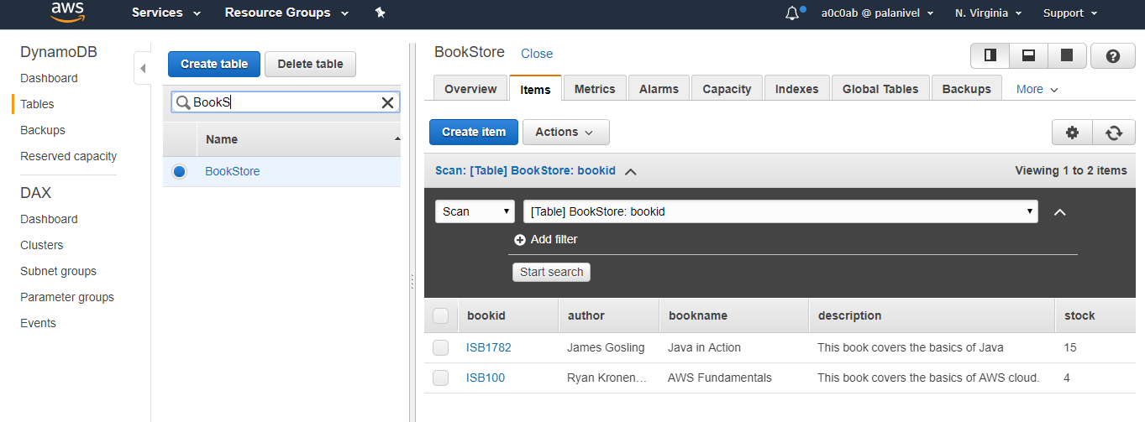

**Lambda**

